Phase 3-Development Part 1

**Noise Pollution Monitoring**

**Design Thinking:**

Project Objectives: Define objectives such as real-time noise pollution monitoring, public awareness, noise regulation compliance, and improved quality of life.

**COMPONENTS**

* Arduino UNO
* LM393 ( Noise sensor)
* ESP32 WIFI Module
* 16*2 LCD Display
* LED
* Buzzer

**Arduino UNO**

Arduino is 8 bit microcontroller board based on the ATmega328P. The operating voltage is 5V. It has 14 pins digital input output pins (Of which can be used 6 as PWM output)

Oscillator frequency is 16 MHz It contains everything needed to support the microcontroller simply connect it to a computer with USB cable. It has 6 analog input pins.

**LM393 ( Noise sensor)**

The sound sensor module provide an easy way to detect sound and it generally used for detecting sound intensity. Module detect the sound has exceeded a threshold value. Sound is detected via microphone and fed into an LM393 op amp

The sound level adjust through pot. The sound increases set value output is low. These module work on DC 3.3-5 voltage.

**Requirement and Objectives of the Project**

The main objective of our Project is to Analysis of the Noise places and providing the

Data of that Noise Place and Provide easy way for Management.

**Innovative things to solve the Noise problems in Our Projects are Listed Below:**

* Floors can offer [remarkable ways of reducing](https://www.conserve-energy-future.com/stepsreducecarbonfootprint.php) noise pollution. However, it depends on the type of floor you have in your place. Carpeting, for instance, usually reduces a substantial amount of noise, but better results can be achieved by the use of noise-friendly flooring like vinyl.
* Furniture is excellent sound absorbers as they reduce echo and sound vibrations. Therefore, sound friendly lounge chairs, bookshelves, couches, and cabinets can affect the acoustics of open spaces.

*Program*

'''

from machine import Pin, ADC

from time import sleep

pot = ADC(Pin(2))

pot.atten(ADC.ATTN_11DB)       #Full range: 3.3v

#ADC.ATTN_0DB: Maximum voltage of 1.2V

#ADC.ATTN_2_5DB: Maximum voltage of 1.5V

#ADC.ATTN_6DB: Maximum voltage of 2.0V

#ADC.ATTN_11DB: Maximum voltage of 3.3V

while True:

  pot_value = pot.read()

  print(pot_value)

  sleep(0.1)

'''

import machine, time

a = machine.ADC(machine.Pin(32))

while True:

    sample = a.read()  # we want 16 bits, a.read() returns 10 bits

    print(sample)

    time.sleep(1/44100)

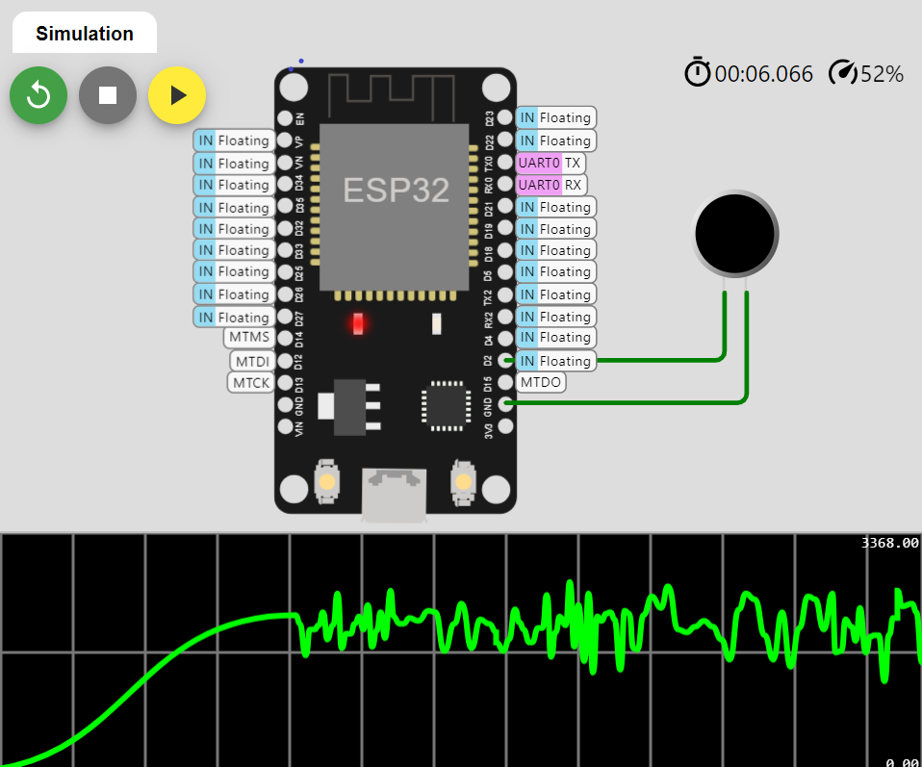

**PROJECT ID : Proj_224688_Team_1**

**NAME : L.Ajay , J.Dilip kumar,V.Dhineshkumar ,Yokesh.J**

**COLLEGE CODE :** 4204